**Full name: ______________**

**Class: 6**

**Week : 11th / 2021**

**PHIẾU HỌC TẬP SỐ 11**

**UNIT 4 : FESTIVALS and FREE TIME - *Lesson 2***

***A. Vocabulary:***

|  |  |  |  |
| --- | --- | --- | --- |
| performance | (n) | /pərˈfɔːrməns/ | màn trình diễn |
| food stand | (n) | /fuːd stænd/ | quầy thức ăn |
| fashion show | (n) | /ˈfæʃn ʃəʊ/ | chương trình biểu diễn thời trang |
| puppet show | (n) | /ˈpʌpət ʃəʊ / | chương trình múa rối nước |
| tug of war | (n) | /ˌtʌɡ əv ˈwɔːr/ | kéo co |
| talent show | (n) | /ˈtælənt ʃəʊ/ | chương trình biểu diễn tài năng |

***B. Grammar:***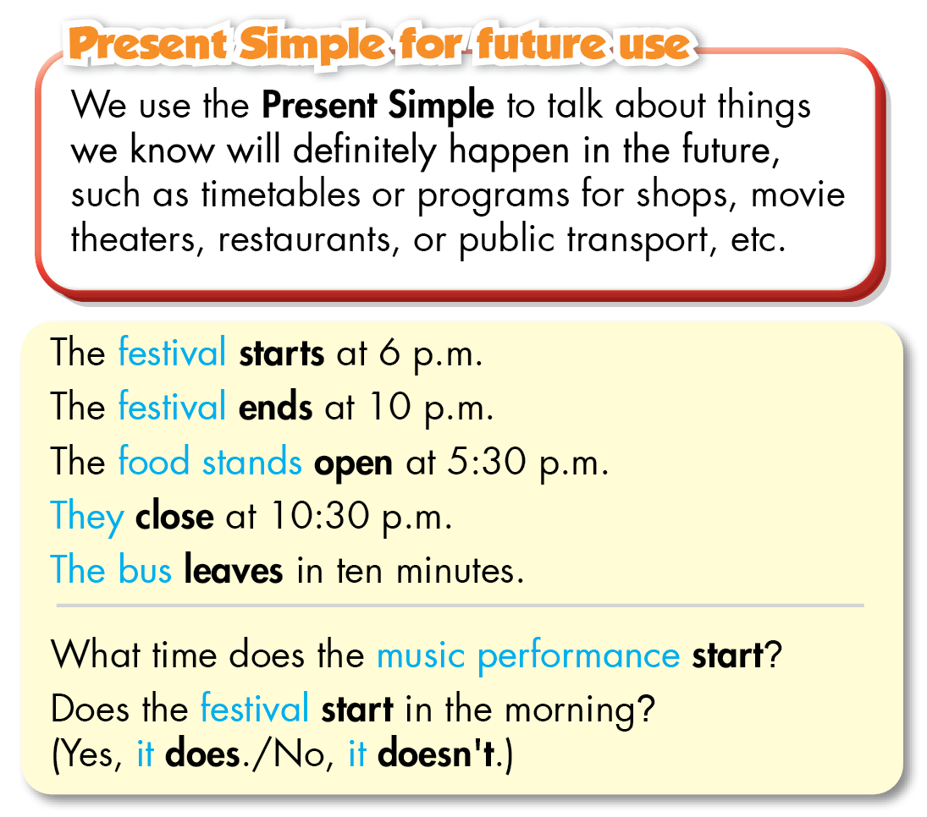

***C. Practice:***

**I.Fill in the blanks with the words from the box.**

|  |
| --- |
| fireworks             get lucky money           eat traditional foods              talent show  always                 ~~rarely~~                             food stands                           never |

*1. I rarely eat fast food. I don't like the taste and it often makes me sick.*

2. My favorite part about Tết is to __________. I usually use it to buy new books.

3. I think you should participate in the __________. You can dance really well.

4. Mary __________ waters her flowers before going to school. She waters them every morning.

5. I want to check out the __________. All the dishes look very tasty.

6. Let's watch __________together. My mom lets us stay up late and you can sleep at my apartment.

7. We __________ go out after eight. My dad doesn't think it's safe.

8. We __________such as stollen, a special cake, on Christmas Day.

**II. Fill in the blanks using the Present Simple.**

1. What time does the music performance *start*? (start)

2. Does the café___________in the morning? (open)

3. The train___________at 4:45 p.m. (leave)

4. What time does the restaurant___________? (close)

5. The puppet show___________in ten minutes. (end)

6. What time does the bus ___________? (leave)

**III.Write sentences using the words below.**

1. We/decorate/houses/Halloween.

2. John/sometimes/play video games/his friends/after school.

3. fashion show/start/8 p.m.

4. How/people/prepare/Christmas

5. How/often/you/go shopping

6. bus/leave/10a.m.

**IV.Read the text messages between Amy and Jim and answer the questions.**

**Amy:** Hi, Jim. Are you free on Saturday?

**Jim:** Sure, Amy. Why?

**Amy:** There's a festival in the park. Do you want to go?

**Jim:**Yeah! What time does it start?

**Amy:** It starts at 10 a.m. and ends at 10 p.m.

**Jim:** Cool! What can we do?

**Amy:** There's a tug of war and a fashion show. Oh, and the food stands open at 10:30 a.m.

**Jim:** Great. You know I'm always hungry! Can we go there by bus?

**Amy:** Yes. There's a bus near my house. It leaves at 9:30 a.m.

**Jim:** I can't wait! See you on Saturday!

1. Where is the festival?

2. What time does the festival start?

3. What activities can they do there?

4. What opens at 10:30 am ?

5. What time does the bus leave?